Taiji Seminar with Paul Fretter

When: Friday 10th Saturday 11th Sunday 12th October 2025
Where: Ashburton Town Hall, Devon
Cost: £180

I'm very excited Paul will be sharing his understanding with us in Ashburton.

As an consultant engineer and technician by trade, Paul draws deeply on his empirical background yet brings an exploratory approach to structure, fluid change and forces in taiji.
This opens up avenues for deep exploration as his passion is push hands.

This is suitable for all levels and styles and will give a thorough explanation of the what and how to practice for maximum benefit of clarity and enjoyment.

Paul trains within the Huang Shen Shyan lineage and offers clear guidance to the subtleties of taiji.
You will view your practice in a whole new light and with fresh eyes.

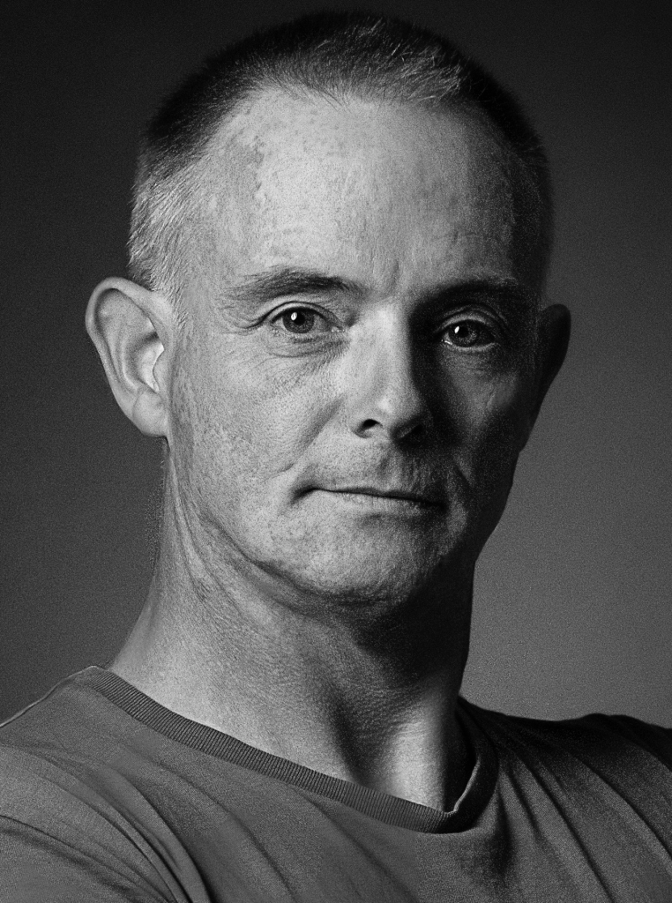
"The most effective way to train Taiji is to understand how the various aspects and exercises relate to each other, and then to train systematically. By highlighting the key principles at play and clarifying the methods used within our system, the workshop will equip students with the knowledge to further refine their practice."

Paul Fretter 2023

Paul has practiced and taught martial arts since the early 1980s and in 2006 was graded to 5th Dan in Okinawan Goju Ryu Karate Do. He began Tàijí as a student of Peter Dobson in 1991, and then followed Peter to learn together under Wee Kee Jin in 1997. Since 2007, Paul has focussed his training on Wee Kee Jin’s Tàijí Quan and White Crane, while maintaining a personal practice of Goju Ryu.
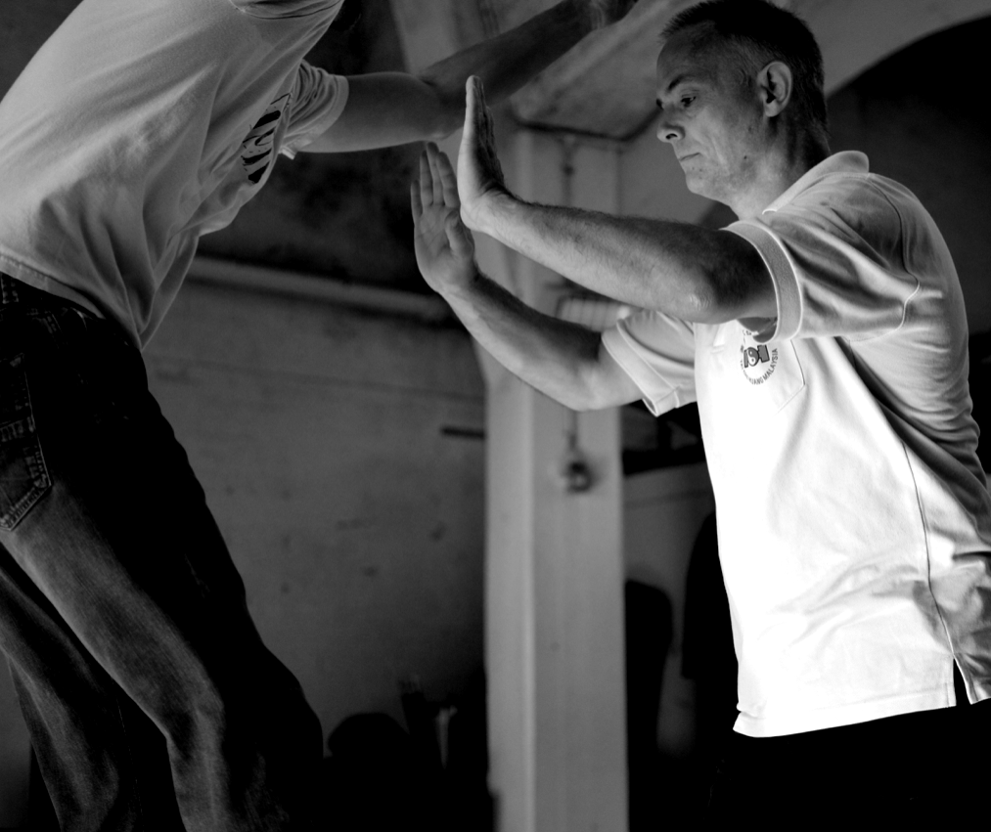
Paul Fretter runs several classes per week in Norwich and on zoom in Taijiquan and Fujian White Crane.
Paul is not currently teaching Karate except on request.
Paul's website and info www.taiji.org.uk

Times: Friday 10th October 11:30am - 2:00pm 2:30pm - 5:00pm
Saturday 11th October 10:00am - 1:00pm 2:00pm - 5:00pm
Sunday 12th October 10:00am - 12:30pm 1:30pm - 4pm

Bookings
Preference given to full 3-day bookings.
Day bookigns available at £70 per day.

To reserve your place please send a non-refundable deposit of £50 by bank transfer to
Luke Shepherd Account 35558407 Sort Code 516118 with your name as reference and email to lukeportrait@gmail.com with your name, address and phone no.

Full details upon booking

More info
e: lukeportrait@gmail.com
t: 0753 158 4898
w: www.openpalm.co.uk

